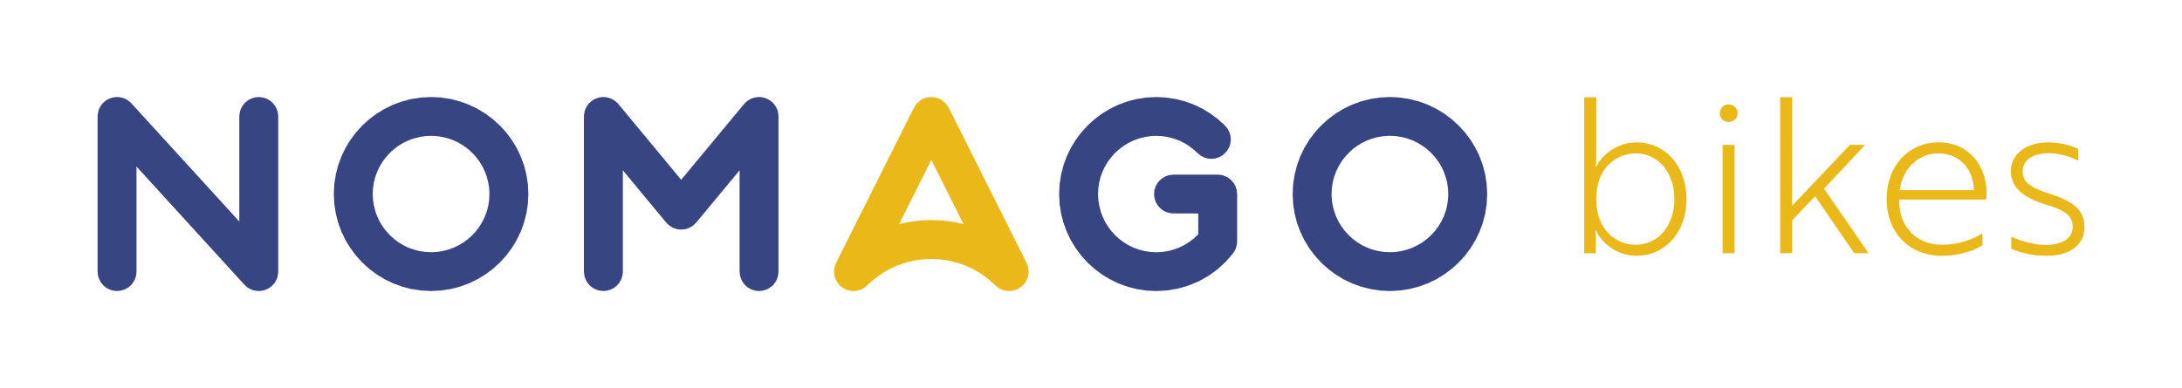 | TARIFFS FOR THE AUTOMATED BIKE-SHARING SYSTEM  Price list 02 · valid from 16.04.2026 | 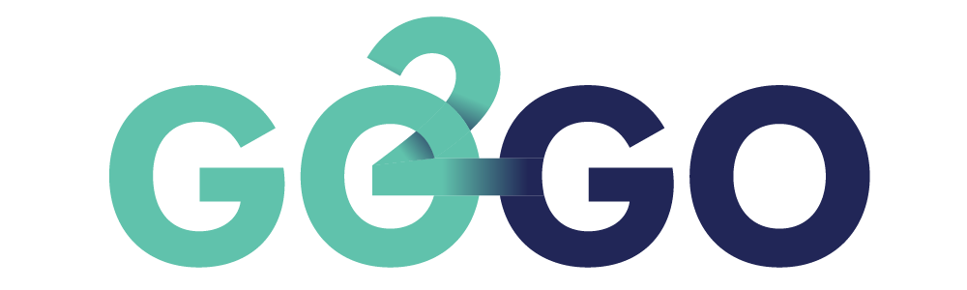

  STANDARD RATE
  Basic minutes package (required for activation) 5,00 €
  → includes 200 minutes of bike rental
  Regular bike 0,50 € / 30 min
  E-bike 1,00 € / 30 min
  Advance reservation (15 min) free
  Maximum daily price 20,00 €
  → daily maximum applies for 24 hours from start of rental
  ANNUAL RATE
  Annual subscription 20,00 €
  Duration 12 months
  First 30 min of each rental free
  Regular bike (after 30 min) 0,50 € / 30 min
  E-bike (after 30 min) 1,00 € / 30 min
  1 bike / 1 user
  Minimum contract period 12 months

FEES AND PENALTIES
Issuance of user card | 3,00 €
Improper bike return (1st offence) | 25,00 €
Failure to lock properly – 1st offence | written warning
Failure to lock properly – each subsequent offence | 10,00 €
Improper use of bike (1st offence) | 15,00 €
Damage / theft – regular bike (negligence) | up to 500,00 €
Damage / theft – e-bike (negligence) | up to 2.000,00 €

ℹ Promotional and partner rates: The provider may publish special promotional or partner rates as part of special campaigns or partnership agreements. Information will be published on the official GO2GO website.

The price list applies to the automated bike-sharing system in the area of the City Municipality of Nova Gorica, the Municipality of Šempeter-Vrtojba and the Municipality of Gorizia (Comune di Gorizia) (nextbike system). For nextbike systems outside Slovenia and/or partner systems, the general terms and conditions of the respective partners apply. In certain cases, the provider reserves the right to change service fees in accordance with actual costs incurred. Return locations are shown online and in the mobile app.

Customer support: +386 1 431 77 60 | Email: bikes@nomago.si | Website: www.nomago.si/izposoja-koles

